
LAUNCHING OF
V
Dr. POONGOTHAI
Hon’ble Minister for Social Welfare, Govt. Of Tamil Nadu
has Kindly consented to be the Chief Guest. and to inaugurate the
”GERIATRIC HOUSE CALL” AND “PUBLIC HEARING”
PROGRAMMES
Dr. VAYU NAIDU, FRSA
Story Taller & Artistic Director, Vayu naidu Co., London has consented lo be the Guest of Honour and to present a
STORY, ON "CARING FOR LIFE"
Dr. V.S. NATARAJAN, MD, FRCP, D Sc(Hon)
Geriatric Physician and Chairman, SCB.
has consented to Preside over the Programmes.
Maj. Gen. ABAN NAIDU, PVSM, AVSM, M in D formerly defence Advisor, Indian Embassy, USA/Canada and Chairman Emeritus, SCB. has consented to Cr his .le'liciftitions.
Your gracious presence is solicited
Dr.V.S. Natarajan Eng.Capt. M.Si nga raja
Chairman Secretary General
Executive Committee Members :
P.S. Santhanakrishnan, 26411938
SBM (Retd ) (Finance & Banking)
Prakash H. Lullah, 26443713
(Personal Administration)
Dr. T.S. Kanaka, 22230935
M.S. M Ch (l-lealth & Medicare)
Sudha Ramalingam, 25352459
P U.C.L. (Legal, Lava, & Order)
Prof. Dr. V. Balarnbal, 24838806
(Educational. Social & Culture)
Dr. P.K. Ponnuswamy, 24832186
IFS (Recd.) (Civ^{i}c Affairs)
M.D. Vijayarangam, R.E. 26216767
R. Seshadri, B.Sc., 26261332
Special Committee Members:
R. Venkatesan, IA&AS. (Rtd.) 24997977
S.P. Ambrose, IAS (Rtd ) 24916494
Prof. Gomathy Narayanan 24833813
K.P. Mahalingam, FIE 26411577
T.V. Hariharan, FIE 22327009
A. Sivasankaran, FIE 24748156
Kousalya Sarathy 28551943
Past Presidents :
Gen. Aban Naidu, 26425555
PVSM, AVSM
V. Hariharan, FIE 26201011
:
S. Murugaiyan, B.E S. Esakkimuthu
Treasurer :
S.K. Vasudevan, B A ,
26425555
26412030
24996905 26216451
28231388
26502424 26282905
24732943
SENIOR CITIZENS BUREAU Chairman Emeritus Gen. Aban Naidu,
PVSM. AVSM
Chairman:
Dr. V.S. Natarajan,
MD. FRCP. DSc (Hon)
Vice Chairmen :
N. Subramanian, IRS (Rtd ) K. Lakshirnikanthan
Bharathi IAS (Rtd.)
Secretary General
Capt.M.Signaraja, C. Eng
SPECIAL ELDER WELFARE PROJECTS
(69th Programme of SCB)
SeniorCitizens Bureau in association with
Kilpauk Residents Welfare Association
cordialiv invites ^{y}ou «vith ^{y}our spouse to attend the programmes
noted below at 11-00 lirs. oii Sun(lay, the 17th February 2008,
In the auditorium of
S('SK0THARI11CADEMYI'0R 1,V0 1FnV (A^{l}eiv A^{l}l. 17, VeilkatapathiSt., Kekys, Clielmai
Invitation
Senior citizens Bureau acknowledges -with thanks the V011111tar.', ' contributions received from the honourable members/donors as detailed -bellow:
- Capt.M.Singaraja (Secy-Gl) Rs. 172/-- Sunshine Fund.
- Indoco Remedies Ltd, Mumbai Rs.3000/- World Elders Day Celebration.

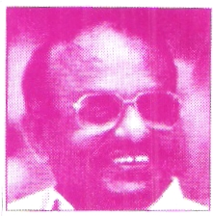
QUESTION & ANSWER
DR. V.S.NATARAJAN, MD, FRCP(Edin), D.Sc.(Hon)
A: Burning sen-
sation in the stomach may be due to too much of acid, ulcer or growth in the stomach. Since the endoscopy is normal, burning sensation is most likely due to too much of acidity. You may take some antacid which will relieve the burning sensation.
What is the reason for burning sensation?

G e n . A b a n N a i d u P.V.S.M.A.V.S.M. M in D
Chairman Emeritus, SCB
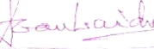
anything which tarnishes the name and prestige of your families,- it is not only⁻you Vivek and you, Anika, but also the harmony and co-existence of the two families which create goodwill. Remember married life is not a bed of roses. There are bound to be differences, quarrels and stand offs, but you should endeavour to compromise, keeping in view the interests of the family – based most importantly on the foundation of Love and Truth. Finally I would say that your aim is to ensure a happy and successful married life –and remember – Love begets love; Love Transcends all Barriers."
Tradition, Culture and time tested values are important facets which should always be kept in mind to lead you on to the rails for a happy married life. Do not do
duce her weight, which will improve her condition (pain). Moderate walking exercise is also beneficial for knee pain.lf there is no improvement, she can go in for physiotherapy.
2. From Mr. S.K.D. Murthy, (AM 265) 15, 5th Street, J.B. Estate, Avadi, Chennai -54.
Q:. I am having burning sensation in the stomach. It is there all the time. My endoscopy is normal.
ful living. Anika there is a saying that behind every man there stands a woman who EGGS him on to do his duty with sincerity and dedication, who encourages him, and tells him not look over his shoulder all the time. Anika, you on the other hand. must run your home with dignity. honour & pride. This is a successful marriage, the like of which God has ordained.
You are not two radio sets, which when, you tune to one frequency gets the same music. But, you are two individuals who have got together with your respective identities, with your aspirations, your own assessment of issues, your ideas and views on subjects, ects, and so on. It is there that the need of resolving issues, arises with- out a rigid approach or an egoistic stand. A difference of opinion could lead to misunderstanding, a quarrel even, and the consequence of this is unhappiness among the members of the family. It also permeates across to friends. and the community you live in – which is undesirable.
1. From Mr. P.Vadivel Raman, (AM 130) 2/5, Narayanan Street, 6th Lane, Pudupet, Chennai- 2
Q: My wife is having pain in both knees for the past 5 years. She is taking treatment regularly. I want to know whether walking exercise
can relieve her pain
A: Yourwife is suffering from Osteoarthritis of both knees. I am glad that she is continuing her medical treatment regulary. If she is obese, she must re-
Prom the Chairman
I feel it relevant to share with the readers some of the points / views expressed by me recently in the midst of prominent well wishers, friends and relatives at the wedding of my grand son. I am the father of Mrs.Viji Vasudev and grandfather of the bridegroom Vivek Vasudev.
"We have gathered here to felicitate Vivek and Anika having been joined together in wedlock. Vivek you are a tal: and a handsome young man and Anika, you are a delightful young lady, and together. you make a charming couple, God Bless you Both.
It is said that marriages are made in heaven, but let me remind you both, that you will be living a life on earth. I have done so – I am an octogenarian –84 years young and I have lived a married life of 61 years, with joy, harmony, with much mutual respect, with spiritual aura and love for each other. Indeed I would say sharing, givin^{g} and taking on a fifty – fifty basis. Likewise I would like to recommend this formula to both of you for a happy and purpose-
TO THE NEWLY WEDDED COUPLE
From the Chairman Emeritus
'A monthly journal of Senior Citizens Bureau
, February 2008 LinkAge

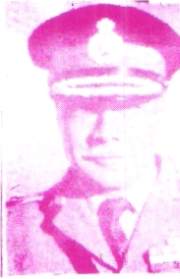

Vimala Rajaram G.V.L. Narayanan P.Gnana Sambandam P.T.Vasudevan R.Santhanam
FITNESS MANTRA
* Never skip meals. It leads to craving of high calorie foods. " Eat Fresh food, salads, fruits and lean m--at.
* Eat more pulses and legumes
* Consume fruits and vegetables liberally and milk products moderately.
* Consume fats, oils and sugars sparingly
*Avoid wrong foods.
AM 508
AM 509
AM 510
AM 511 AM512
Welcome into our family fold
I. New members
Your voluntary contribution for Sun Shine Fund is
most welcome
01-07 International Development Week
02 World VVI-Itland day
12 - Darwin's Birthday
14 World ValenJne Day
15 (i) World Kidney Day (ii) Galileo's Birthday
20 World day of Social Justice.
21 World Mother Tongue day
24 Central Excise day
28 National Science day.
II. RENEWAL OF ANN UAL
MEMBERSHIP 2007-08
- D.Sundaramoorthi AM 358
- N.BalajiSingh AM 308
- S.Esakkimuthu AM 370
AM368 S.P.Balachandran AM184 G.Krishnan. AM380 G. Ramesh Babu AM454 K.Sadasivam LM461 K.Ponnuswamy LM314 Dr.A.R.Emperumal LM460 S.Arumugam LM159 V.RaJagopal AM072 Dr. P.Krishnamurthy AM464 S.Jagadeesan
AM467 S.Janaki
AM468 S. Rangabashyarn
- 16.02.1940
- 20.02.1944
- 24.02.1942
- 27.02.1935
- 06.03.1931
- 07.03.1935
- 08.03.1947
- 09.03.1949
- 14.03.1931
- 14.03.1935
- 14.03.1931
12, 15.03.1932
WISHING YOU A CHEERFUL, PEACEFUL AND LONG LIFE SI.NoDate of Birth Membership Name
National & Internet onal Day's'IM8
BIRTH DAYS 16th Fe6— 16th-March
I
seldom focused. There is no slot in TV for such great motivating factors. In our monthly Journal "LinkAge", we publish the Nat^{i}onal / International days, earmarked during the month, just as a reminder, for the benefit of all.Every youth is bound to shoulder some social responsibility / support to upkeep our own native civilization. They can. be motivated and rewarded with proper drives. We are not having dearth of appropriate drivers. We must prioritise to rally behind people like Dr.A.P.J. Abdulkalam.
Eng. Capt. M. Singaraja, BE, PGDBM, FIE, FIV, MSc (Psy).
days are rarely recognized. Regional / National / International contributors to humanity, Science & Technology and common cause are

February 2008 LinkAge
A monthlyjournal of Senior Citizens Bureau

From the Editor / Secretary General
PRIORITISE OUR CIVILIZATION
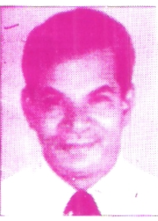
Our Print, Electronic and Cyber media are creating sensation and hype about newly found days of the West, such as New year day and Valentine day.
The business organizations and commercial traders are adcpting innovative sales techniques to market their products in the name of such days. The Hospitality Industry is throwing jazz parties in the star hotels, resorts and tourist spots.
Our youths become an easy prey. carried away by attractive ads. gifts and gestures. They reach- out to the products and services brought out for these celebrations, either out of their self or family earnings-, this may or may not be righteous. Somehow or other. these are affordable to them. In most of the cases, all types of abuses are indulged
in by our misguided youth, in connivance with the marketeers mentioned above. including the media directly or indirectly, who make huge money. We witness accidents, murders, fights, rapes, losses, out of which only a few cases surface. In the process, these Youths stray away from our civilization of family and social gettogether, during happy or sad occasions like wedding, festivities, death etc. Their participations are becoming rare and rare. They do not avail of leave of absence to attend. Family / Social order is diminishing as a result. Their social behaviour is undergoing a tremendous change. ^{I} wonder whether we can call this as liberal and global out sourcing. Togetherness in the family and in the society is distancing itself. It is a concern for the civil society and righteous people. National and international
If.undelivered please return to
SENIOR CITIZENS BUREAU
(A.0.) No., B-30. 1st Floor, Anna Nagar (East), Chennai - 600 102. Ph : 2628 2018, 28231388
LinkAge
Published in the Second Week of Every Month
Posted at Patrika Channel, Egmore RMS on 8 - 02- 2008/-
To
293 PHONE:044-26502424 MURUGAIYAN, S.
PLOT NO.71, DOOR NO.4, 2ND STREET, NORTH JAGANATHA NAGAR, VILLIVAKKAM,
CHENNAI-600049. TAMILNADU.
Published by Eng.Capt. M. Singaraja on behalf of Senior Citizens Bureau, (R.O.) New No.90, Rarna Naicken Street,
Nungan7bakkam, Chennai - 600 034. Ph : 2823 1388. Printed by Srikalaivani at Sri Maruthy Laser Printers. 173, Peters Road,
Royapettah, Chennai - 600 014. Ph : 2852 4256. Editor : Capt. M. Singaraja, C.Eng. Secretary / Publication : Eng. S. Murugaiyan.
The scheme will cover 1.2 crore BPL workers this year (2008-09) and the total expenditure is likely to cost the government Rs.973.50 crore.
All families below the poverty line (BPL) will get health insurance cover under the Rashtriya Swasthya Beema Yojana from April 1. 2008. The Smart Card will carry details of a BPL worker and his family with a photograph.
Minister of State for Labour and Employment Oscar Fernandes released on 25.01.2008 a"Smart Card" that will entitle the holder to health insurance cover up to Rs.30,000 through listed hospitals.
HEALTH INSURANCE FOR BPL FAMILIES
A Section of participants undergoing tests BMD Test in progress
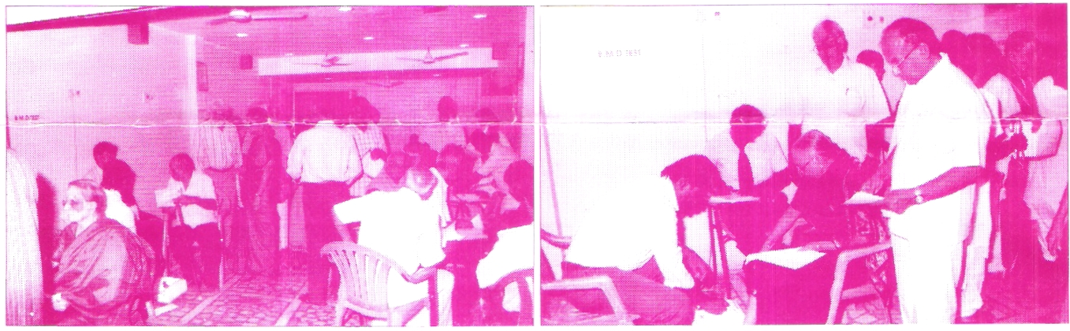
bers of the Bureau TvI.S. K.Vasudevan, Kausalya Sarathy, Prakash H. Lullah, S. K. D. MUrthy, M.Subbian. S.Esakkimuthu and H.Azariah took active part for the successful conduct of the camp. Totally 57 persons attended the screening camp.
S.Murugaiyan Secretary
guided the participants to undergo the required tests. Volunteer mem-
B.M.D (Bone Mineral Density) and BMI (Bone Mass Index) tests were conducted using machines to assess the strength of bones. The orthopedic surgeon offered necessary advice to the participants on the care needed to prevent/ manage deformities, fracture, arthritis and osteoporosis.
The team of physicians consisting of Dr. Lakshmipathy Ramesh and Dr.Shanthi was headed of Dr.V.S.Natarajan. Geriatrician.
Volunteers from the community college of YVVCA assisted and
Senior Citizens Bureau organised a Screening Camp on Healthy Mind & Healthy Bones at Kumaran Hospital, Kilpauk, Chennai — 10 on 26.01.2008, in association with (i) Eisai Pharmaceuticals India (P) Ltd, Mumbai (ii)Activa - a division of IPCA Laboratories Ltd, Mumbai (iii) Ordain Health care (P) Ltd, Chennai and (IV) Meyer Organics (P) Ltd Thane.
After recording height, weight, B.P. and Random Blood Sugar level. a team of psychologists evaluated the memory status of the participants for appropriate intervention by a team of physicians.
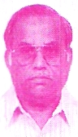
Activities-Report Fi6ft,secretary | Screening Camp on Healthy Minds &  Healthy Bones (68th Programme of SCB)

(₄ ₎ February 2008 Regd with Registrar of Newspapers for India No. TNE NG/2004/13996 - Postal Regn. RNP No. TN/CH @ 37/07- 09.
A monthly journal of Senior Citizens Bureau Licensed to post w/o prepayment vide WPP No.41/07-09

